Stirling & Clackmannanshire
Strategic Commissioning
Plan
2023-2033

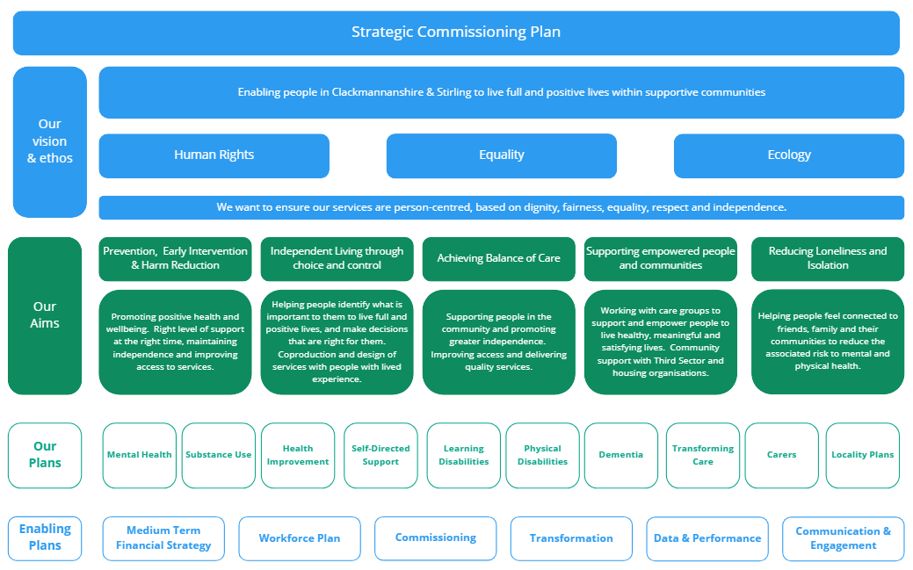

Contents
Part 1 | Context | Introducing the Strategic Commissioning Plan Purpose, strategic context, nationally and locally Statistics, challenges and opportunities
Part 2 | Our Priorities | Prevention, early intervention and harm reduction Independent Living through choice and control  Care Closer to Home  Supporting independent people and communities  Loneliness and Isolation
Part 3 | Our Principles | Human rights, equality, ecology, Independent living, choice & control, Lived and living experience
Part 4 | Engaging our People &  Communities | Engagement and participation  Locality planning  Commissioning Consortia
Part 5 | Our Enabling activities | Finance, workforce, service planning, data and performance, transformation, commissioning?
Part 6 | Our Data | Demographics, Strategic Needs Assessment, Scottish Burden of Disease  Health and social care need.
Part 7 | Measuring Success | Governance – how we will monitor/report  Performance and action plans  How will we know we have been successful?

Our Vision is to ensure care and support is person-centred,
based on dignity, fairness, equality, respect dignity and autonomy.

Feeley
Everyone in Scotland will get the social care support they need to live their lives as they choose and to be active citizens. We will all work together to promote and ensure human rights, wellbeing, independent living and equity

PHOTO

Acknowledgement
The IJB would like to thank everyone who has worked with us to develop this Strategic Commissioning Plan and shape the future of health and social care in Clackmannanshire and Stirling. We greatly appreciate you giving your time, sharing your knowledge and your experiences to create this with us. We will continue to work with you over the course of this Plan.

Context
Although the Strategic Commissioning Plan is a requirement set by the Public Bodies (Joint Working) (Scotland) Act 2014, the focus of this Plan is integrated working, partnership opportunities and co-production with those with lived and living experience to deliver a quality system of care and support .This aligns to the principles of legislation which sets out the framework for integrating adult health and social care, to ensure a consistent provision of quality, sustainable care services for the increasing numbers of people in Scotland who need joined-up support and care, particularly people with multiple, complex, long-term conditions.

The Strategic Commissioning Plan lays out the national and local context required and outlines the legislation and national and local frameworks as well as links to the National Health & Wellbeing Outcomes.

What is the Strategic Commissioning Plan?
The Public Bodies (Joint Working) (Scotland) Act 2014 requires Local Authorities and Health Boards to delegate some of the functions of health and adult social care services. The Integration Joint Board (IJB) is responsible for the strategic planning of these functions delegated to it and for ensuring the delivery of those functions.

The Public Bodies (Joint Working) (Scotland) Act 2014 places a duty on IJB to develop a “strategic plan” for integrated functions and budgets. It sets out the arrangements for delivering of local services in locality areas and must set out the arrangements to contribute towards achieving the national health and wellbeing outcomes.

Clackmannanshire & Stirling Health and Social Care Partnership (HSCP) brings together integrated health and social care services; it is the delivery vehicle for the delegated functions from across Clackmannanshire Council, Stirling Council and NHS Forth Valley. It is a unique partnership in Scotland as it is the only Health and Social Care Partnership that brings together two councils and a health board.

What the plan will do
In this Strategic Commissioning Plan, we set out our key themes and priorities based on what people have told us; where they wish for us to focus our activity and resources based on local demographics, population and need. The participation and engagement work carried out with communities, partners and stakeholders and how this feedback alongside current data informs our priorities. We have also linked our priorities to the national and local environment and how our Enabling activities support our delivery.
This Plan is divided into sections and these follow the process of locality and service planning. The first section sets out the context of the Strategic Commissioning Plan and environment within which the HSCP operates; describing the national and local context which contributes to and introduces our priorities.
We set out our themes and priorities and the driving Principles for delivery, behind the Strategic Commissioning Plan that focus on human rights, equalities, ecology, and independent living through choice and control.
We then look at Engaging our People and Communities. This defines the collaborative approach to service delivery though involving the people who access health and social care services, the people who provide health and social care services. At the heart of this is the Commissioning Consortium and Locality Planning Networks.
Enabling activities describes the technical details that help us deliver services, finance, workforce planning, transformation, data and performance and service planning. We then look at Our Data, the information we need to gather and analyse to understand people and their need.

Functions delegated to Clackmannanshire & Stirling IJB

Our partnership is responsible for planning and commissioning integrated services and overseeing their delivery. These services cover adult social care, adult primary and community health care services and elements of adult hospital care.

The HSCP has a strong relationship with acute health services and Community Planning Partnerships, the third sector organisations, independent sector and other public sector bodies to deliver flexible locality based services, including services commissioned on a Forth Valley wide basis. Planning and designing services is in collaboration with communities and people with lived and living experience.

NHS services delegated to CSHSCP  - District Nursing  - Substance addiction or dependence services  - Allied Health Professional services in outpatient clinics/out of hospital  - Public dental services/Primary medical services including out of hours, general dental, Ophthalmic & Pharmaceutical services  - Geriatric medicine and palliative care outwith hospital  - Community Mental Health & Learning Disability services  - Continence and kidney dialysis outwith hospital  - Public Health and Improvement. |  | Clackmannanshire & Stirling services delegated to CSHSCP  - Social work services for adults aged 16+  - Services and support for adults with physical disabilities  - Services and support for adults with learning disabilities  - Mental health services  - Drug and alcohol services  - Adult Protection and domestic abuse  - Carers support services  - Community Care assessment teams  - Support services  - Care home services  - Adult Placement services  - Health improvement services  - Aspects of housing support and assistance including aids and adaptations  - Day services  - Respite provision  - Occupational therapy, equipment and telecare

Strategic Context

The Strategic Commissioning Plan links and contributes towards the wider outcomes and priorities, including the United Nations Sustainable Development Goals ; Scottish Governments National Performance Framework and National Health and Wellbeing Outcomes as well as locally taking consideration of the contribution partnership local authorities, health board and other local partnerships. The policy landscape is continually evolving, not least with the impact of COVID-19 and the development of the National Care Service. Delivery of health and social care services in Clackmannanshire and Stirling reflect and aligns to the national and local policy environment and it is important that we are flexible and open to these changes.

National Context |  |  | Local Context
Legislation & Policy | Strategies & Guidance |  | Strategies & Guidance
UN Sustainable Goals  Scottish Government National Performance Framework  National Health and Wellbeing Outcomes  Social Work (Scotland) Act 1968  Community Care and Health (Scotland) Act 2002  Social Care (Self-directed Support) (Scotland) Act 2013  Public Bodies (Joint Working)(Scotland) Act 2014  Community Empowerment (Scotland) Act 2015  Carers (Scotland) Act 2016  Social Security (Scotland) Act 2018  2018 General Medical Services Contract in Scotland  Housing to 2040 | National Clinical Strategy for Scotland  Realising Realistic Medicine  Health and Social Care Standards  A Fairer Healthier Scotland  Public Health Scotland’s Strategic Plan  Digital Health and Social Care  SDS Framework of Standards  Independent Review of Adult Social Care  National Care Service  NHS Recovery Plan  Scottish Government Strategic Framework  COVID Recovery Strategy  Scottish Government Alcohol Framework 2018  Scottish Government Rights, Respect & Recovery strategy |  | Clackmannanshire Council  Corporate Plan  Community Planning Partnership Local Outcome Improvement Plan  Forth Valley NHS  Remobilisation Plan  Healthcare Strategy  Annual Delivery Plan  Stirling Council  Thriving Stirling  Community Planning Partnership The Stirling Plan  Third Sector  Independent Sector  Falkirk Council

Our Strategic Themes
Our priority is to provide health and social care services that support people to meet their outcomes, services that are high quality, fulfil the needs of people and help individuals to live independent and fulfilling lives.

Prevention, early intervention and harm reduction
Working with partners to improve overall health and wellbeing and preventing ill health. Promote positive health and wellbeing, prevention, early interventions and harm reduction. Promoting physical activity, reduce exposure to adverse behaviours. Right levels of support and advice at the right time, maintaining independence and improving access to services at times of crisis.

Independent Living through choice and control
Supporting people and carers to actively participate in making informed decisions about how they will live their lives and meet their agreed outcomes. Helping people identify what is important to them to live full and positive lives, and make decisions that are right for them. Co-production and design of services with people with lived experience who have the insight to shape services of the future.

Care Closer to Home
Shifting delivery of care and support from institutional, hospital-led services towards services that support people in the community and promote recovery and greater independence where possible. Investing in and working in partnership with people and communities to deliver services. Improving access to care, the way services and agencies work together, working efficiently, improving the customer journey, ensure people are not delayed in hospital unnecessarily, co-design of services, primary care transformation and care closer to home.

Supporting empowered people and communities.
Working with communities to support and empower people to continue to live healthy, meaningful and satisfying lives as active members of their community. Being innovative and creative in how care and support is provided. Support for unpaid carers; helping people live in their local communities, access to local support, dealing with isolation and loneliness. Planning community supports with third sector, independent sector and housing providers. Neighbourhood care, unpaid carers, third sector supports.

Reducing loneliness and isolation
Our society is changing, accelerated by the pandemic and there is increasing risk of social isolation and loneliness, both of which can impact a person’s physical and mental wellbeing. We will work with communities to support local communities to build connections.

Operating Environment for the next 10 years
“The delivery of this plan will be influenced by the following challenges we face within our operating environment and how we will work to resolve them”.

- Continued recovery and learning from COVID-19
- Budget responsibility
- Flexibility of care and support
- Service modernisation and transforming care
- Demographic changes & burden of disease
- Place based activity and environmental impacts
- Resilience of communities and workforce
- Engagement, participation and empowerment
- Supporting partners and stakeholders to manage change

As we proceed over the next ten years we will continually review our operating environment and how any changes may impact on how we will work. The detail in the following sections outlines what we will achieve over the lifetime of this Plan.

The Independent Review of Adult Social Care and the National Care Service (NCS)
The Independent Review of Adult Social Care recognised the strengths and challenges within community health and social care and the Scottish Government have since legislated to introduce the National Care Service (NCS). At the time of writing the Strategic Commissioning Plan, the NCS is in development, with engagement work still underway, so at this time, the extent of change is undetermined.

The development of a National Care Service will have a significant impact on the planning and delivery of health and social care services in future. However, while the NCS is being developed, we will continue to work within the principles of the Independent Review and NSC consultation such as human rights based approach; empowering people, choice and control, preventative approached and continuous improvement.

We will also continue to participate and engage with the shaping and design of the NCS and our Strategic Planning Group will monitor progress and advise the IJB.

Risk
The Integration Joint Board (IJB) monitors and seeks to mitigate significant risk through its Risk Management Framework and corporate Strategic Risk Register.

The Audit & Risk Committee provides a scrutiny role for the Integration Joint Board by reviewing, scrutinising and approving the Strategic Risk Register. Risks are routinely reported to the IJB through quarterly and annual Performance Reports.

Of specific note is the risk in relation to workforce, which is multi-factorial, and poses significant risk to achievement of the IJBs goals and strategic priorities. Focused work to understand and identify mitigating strategies and actions is considered with the Strategic Workforce Plan (LINK)
The IJBs risk management framework is reviewed regularly, considering any updates required to the risk management framework and improving interfaces with risk management arrangements across the constituent authorities assisting in linking operational and strategic risk identification, management and reporting.

Best Value (& Clinical & Care Governance???)
Best Value is a duty that applies to all public bodies in Scotland, including IJBs. It is a statutory duty (a law that must be followed) for local authorities and a formal duty for other public bodies such as the NHS.

In order to achieve Best Value, we must demonstrate good governance and effective management of resources to deliver the best possible outcomes for the public. This means we must identify and define our outcomes and priorities, plan how we will achieve these and monitor and report progress.

It is based on the values of openness and transparency, allowing the public to understand decisions made, how resources are being utilised and how we are working to deliver services and improve outcomes. This means having balanced conversations and reporting on decisions and progress and collecting and publishing relevant and accurate performance information, to demonstrate Best Value. This allows for effective scrutiny and accountability.

Engagement with the public and communities is a significant part of Best Value in that we must involve people and communities in the work we do, the decisions we make and the services we design. This can only work if we provide information, analysis and report in an open and transparent way and give the public opportunities to be involved.

This Plan has been developed with the principles of Best Value and engagement woven throughout the priorities as well as within the accompanying Performance Management Framework.

Integrated Performance Management Framework
To ensure that performance is open and accountable, the 2014 Act obliges HSCPs to publish an annual performance report setting out an assessment of performance in planning and carrying out the integration functions for which they are responsible.

The purpose of the performance report is to provide an overview of performance in planning and carrying out integrated functions and is produced for the benefit of HSCPs and their communities.

The HSCP has an integrated performance framework which is based on the key priorities outlined within this Plan as well as Winter Plans, Integrated Workforce Plan, Unscheduled Care Planning, Intermediate Care planning and Locality Planning Networks. This framework supports a robust reporting schedule, reporting on key performance indicators, national and local targets as well as the opportunity to benchmark.

Our Priorities
Our priorities have been identified through data and conversations with communities and individuals. We have aligned these with five overarching themes that describe our intentions. These are linked to the National health and wellbeing outcomes.

For each of the themes, we outline the related priorities, what we intend to achieve and what success will look like. We have also included some stories from the people with lived experience of the services and the outcomes achieved working together. We have also provided links to relevant strategies and work that is underway.

National Health & Wellbeing Outcomes
All themes and priorities are linked to the Health and Wellbeing Outcomes, some more directly than others. Each theme will demonstrate improvement for people and communities, how we are embedding a human rights based approach, consideration for equalities and evidencing improvement across the services we deliver  Health and Wellbeing Outcome | Prevention,  early intervention &  harm reduction | Independent living through choice  and control | Care Closer  to Home | Supporting empowered people & communities | Loneliness &  isolation
1. People are able to look after and improve their own health and wellbeing and live in good health for longer.
2. People, including those with disabilities or long term conditions, or who are frail, are able to live, as far as reasonably practicable, independently and at home or in a homely setting in their community.
3. People who use health and social care services have positive experiences of those services, and have their dignity respected
4. Health and social care services are centred on helping to maintain or improve the quality of life of people who use those services.
5. Health and social care services contribute to reducing health inequalities
6. People who provide unpaid care are supported to look after their own health and wellbeing, including to reduce any negative impact on their caring role on their own health and wellbeing.
7. People who use health and social care services are safe from harm
8. People who work in health and social care services feel engaged with the work they do and are supported to continuously improve the information, support, care and treatment they provide. | Enabling Activities
9. Resources are used effectively and efficiently in the provision of health and social care services

Prevention, early intervention & harm reduction
Promoting positive health and wellbeing, the right level of support at the right time, maintaining independence and improving access to services

Priority 1 Mental Health & Wellbeing (including the impact of COVID-19
Priority 2 Drug and alcohol care and support capacity across communities

Links to Strategies and Plans
Mental Health
Suicide Prevention Health Improvement
ADP
Suicide Prevention
Delivery Plan 2020-2023 Rights, Respect & recovery
Alcohol Framework
Improving support for Mental Health
Prevention is about helping people stay healthy and independent for as long as possible and reducing the chances of problems arising, and if they do, supporting people to manage them as effectively as possible.

Early intervention identifies and provides effective early support to those at risk of poor outcomes and harm reduction is used to decrease the negative consequences and recognises where someone is unable to stop, can still make positive change to protect themselves and others.

While our services are needs led, we are also resource bound, to improve outcomes for people, we need to prevent and avoid crisis and help people improve their health and wellbeing.
We will:
- Work with partners to improve overall health and wellbeing and prevent ill health.
- Promote physical activity reduce exposure to adverse behaviours. Right levels of support and advice at the right time, maintaining independence and improving access to services at times of crisis.
- Reducing the burden of substance related harm, rehabilitation, access to treatment, together, across the partnership.
- Redesign of mental health services, suicide prevention, and redesign of psychological therapies - but also could include wellbeing, improving access to services and support for mental health. Bereavement, social prescribing, third sector support.
- Early signposting to services.

Independent living through choice and control
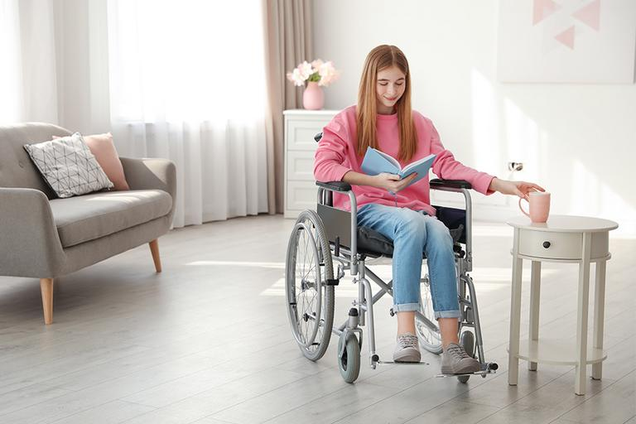 | Promoting positive health and wellbeing. The right level of support at the right time, maintaining independence and improving access to services  Priority 3 Self-Directed Support information and advice promoted across all communities  Priority 4 Support those affected by dementia at all stages of their journey  Links to Strategies and Plans  Self-Directed Support Care Closer to Home Supporting People living with Dementia Learning Disabilities Frailty Falls Palliative Care & End of life
Independence can boost self-esteem and confidence, improve someone’s sense of purpose and quality of life and therefore boost their physical and mental health.  It is important that people are aware of their rights and how they should access the support they want to achieve the outcomes that are important to them. Services designed by people who are living or have lived this experience are best placed to help us design services. It is also important that people know what is available and what choice they have.  Conversations with our communities, service users and staff have highlighted this as important and integral to our principles of human rights, equality and realistic medicine. | We will:  - Supporting people and carers to actively participate in making informed decisions about how they will live their lives and what outcomes they want to achieve.  - Helping people identify what is important to them to live full and positive lives, and make decisions that are right for them.  - Coproduction and design of services with people with lived experience who have the insight to shape services of the future.

Achieving balance of care
Promoting positive health and wellbeing, The right level of support at the right time, maintaining independence and improving access to services

Priority 5 Good public information across all care and support working
Priority 6 Workforce capacity and recruitment

Links to Strategies and Plans
Primary Care Improvement Plan
Primary Care and Mental Health Plan
Integrated Workforce Plan
Alcohol & drugs?
The growing demand in population and people with health and social care needs and their complexity, while public services face increasing pressure on resources has led to the realisation that we must transform our services.  We know people want to be supported to stay in their own homes and communities for as long as possible. Achieving balance of care, is about changing how services are accessed and making them fit for purpose and modern. Technology can deliver so many benefits and improve the way we communicate and access services.  It is about reducing cost, while increasing effectiveness and capacity and allowing resources to be allocated better. | We will:  - Supporting people and carers to actively participate in making informed  - Work with partners to improve overall health and wellbeing and prevent ill health.  - Promote physical activity reduce exposure to adverse behaviours. Right levels of support and advice at the right time, maintaining independence and improving access to services at times of crisis.  - Reducing the burden of substance related harm, rehabilitation, access to treatment, together, across the partnership.  - Redesign of mental health services, suicide prevention, and redesign of psychological therapies - but also could include wellbeing, improving access to services and support for mental health. Bereavement, social prescribing, third sector support.  - Early signposting to services.

Supporting empowered people and communities
Promoting positive health and wellbeing. The right level of support at the right time, maintaining independence and improving access to services

Priority 7 Support for Carers
Priority 9 Develop locally based multiagency working across communities
Priority 10 Ethical Commissioning

Links to Strategies and Plans
Carer's Strategy Third Sector in Communities
Carers’ Eligibility Criteria Palliative Care & End of life

Empowerment is the process of becoming stronger and more confident, especially in controlling one’s life and claiming one’s rights. In health and social care, empowerment is defined as a process through which people gain greater control over the decisions and actions that affect their lives. Empowerment is important for everyone involved in care, including the service users, their families, loved ones and care workers.  Bringing the knowledge, skills and experience of people and communities together and working in co-production to improve access and outcomes. | We will:  - Work with care groups to support and empower people to continue to live healthy, meaningful and satisfying lives as active members of their community.  - Being innovative and creative in how services are provided.  - Support for unpaid carers; helping people live in their local communities, access to local support, dealing with isolation and loneliness.  - Planning community supports with third sector and housing organisations. Neighbourhood care, unpaid carers, third sector supports.

Loneliness & isolation
Connecting people to their communities, reducing loneliness and isolation and the impact on people’s health and wellbeing.

Priority 11 Reducing levels of loneliness and isolation

Links to Strategies and Plans
Link to Third Sector Interfaces
Locality Plans in Communities
Carer's Strategy

Loneliness and social isolation are not the same. Not everyone who is socially isolated feels lonely; and those who are not socially isolated may experience a sense of loneliness. Loneliness is a feeling of lack or loss of companionship. It happens when we have a mismatch between the quantity and quality of social relationships that we have, and those that we want.  Social isolation refers to the number of relationship and social interactions someone has, and can be measured. Being lonely of socially isolated can have long-lasting and negative impacts on physical and mental health and wellbeing. Social relationship and networks can promote health and wellbeing for people at any age. | We will:  - Work towards making Clackmannanshire & Stirling places where everyone feels safe, welcomed, connected, included and valued.  - Facilitate new connections – Working with partners to create a vibrant offer to people, to encourage people to try something new and make connections.  - Encouraging volunteering, helping people keep active, and supporting intergenerational activities and identity based groups such as faith, BME and LGBTQ+ communities.  - Interrupting triggers – We will support residents who are moving from one life phase to another, including those recently bereaved and those who have become carers.  - Finding new and innovative ways to tackle loneliness – we will look for new and ways for residents to engage and help build local connections and a sense of belonging.  - Changing the narrative around loneliness by raising awareness of loneliness and social isolation and finding new ways to enable people to ask for help without feeling awkward or embarrassed.  - We will consider loneliness and social isolation in our everyday work.

Principles for Delivery
We acknowledge our role as a social institution in protecting the people we serve and improving their lives. We are committed to delivering care and support within a human rights, equality and ecology value-based framework.

This framework will support the delivery our key responsibilities to plan, commission, deliver and review all adult care and support. Over the next few years, we will be working to embed these principles and engagement in the planning, commissioning and delivery of care and support.

Human Rights, Equalities & Ecology
Caring is natural to humans, it connects us with others and can define us. When we care for people, or are cared for, we are uniquely connected to others. Care is both an activity and a quality: everyone can care for others, and everyone can benefit from care.

The HSCP’s core purpose is to ensure people have available care and support based on meeting their outcomes, where and when it is required. We deliver this through joint planning, commissioning and co-production and by reviewing care and support for people across our communities to create the conditions for each individual to flourish. Describe what we mean by ecology (natural world affects communities and individuals health and wellbeing importance of the natural world affects communities and individual’s health and well-being.

We want to ensure our services are person-centred, based on dignity, fairness, equality, respect and independence.

Human Rights
As part of our strategic planning process we have explored how the HSCP can embed human rights-based approaches in its practice, as a means of countering the effects of inequality and addressing ecological concerns. Our aim is to realign systems of care to respond to needs identified by people and their communities. Doing this requires us to actively restructure our decision-making around people’s living and lived experience.

This starts by supporting the development of rights-based practice across our partnership. Some services already have significant experience here, and we can learn from them as we encourage other services to evolve their practice in line with respect for every individual and their human rights. We will do this in line with the Scottish Human Rights Consortium’s ‘PANEL’ approach. The PANEL approach helps services to demonstrate their Participative nature, they have Accountability, are Non-Discriminatory, focused on Empowerment of people and operate within a clear framework of Legality.

As an HSCP we are mindful of our responsibilities as a duty-bearer in relation to people’s rights. A rights-based approach ensures protection for those being cared for, recourse where discrimination or non-equality arises and accountability on the part of systems and those working within them.
We will support human rights by;
- Endorsing PANEL and FAIR (Facts, Analyse, Identify and Review) practice, in line with Scottish Human Rights Consortium guidance, consistently across our strategic commissioning and planning.
- Embedding Rights-based approaches across the HSCP’s work, and reflected within the development of plans and policies.
- Create the conditions for a culture of rights-based practice in the early years of the 10 year Strategic Commissioning Plan.

Equality
Evidence through the Strategic Needs Assessment and Burden of Disease work across Clackmannanshire and Stirling, suggests significant areas of inequality for some communities, including inequalities linked to health outcomes.
We will act to support individuals who need support amidst the cost of living crisis, which disproportionately affect those already impacted.
We will focus on the effects of inequality on people’s capacity to care and their need for care and support. We recognise that inequality is not just relative to economic status, but people’s capacity to contribute and be rewarded for their contribution.
We will support equality by:
- Developing asset-based community development (ABCD) as already being developed by Clackmannanshire’s Resilience Learning Partnership. Supporting the emergence and development of new economic models which encourage fair participation and equitable access to meaningful use of time through the commissioning consortium and wider commissioning responsibilities.
- Consistent assessment during strategic planning processes of the effects of inequality, with the HSCP striving to work to address these where possible.
- Work with partners to align HSCP resources where possible to the development of ‘public option’ community-owned assets where markets enforce inequalities (examples may include food availability, transportation, and childcare).

Ecology
Through the Locality Planning Networks, and feedback from individuals and partners across Clackmannanshire and Stirling, it has been clearly recognised that the importance of the natural world affects communities and individual’s health and well-being.

Outdoors is more than just restorative, it is an object of care for communities particularly based in rural areas and the natural environment that surrounds us.
We also recognise the built environment has a place of importance in shaping people’s health and wellbeing, it has close relationships to people’s capacity to care and their own care needs. Individuals have voiced concerns for the natural environment within community and engagement meetings with the HSCP. But, like rights and equality, it is a question of ensuring that we adapt our framing and integrating ecological concerns into our practice and within our reach.
Access to the natural environment and green space improves health, reduces physical health and inequalities, improves mental health and resilience and social capital. The interconnectedness of ecology, the web of life, also provides us with an understanding of the health and social care system we would like to continue to develop.
We believe that the health of our people, workforce and communities is linked to the health of our environment. Ecology can also be useful to help frame the HSCP’s focus on prevention in a new context, seeking to ensure a rounded response by including place and the living environment as part of our response.

How we will support ecology?
- Supporting ecological awareness in strategic planning across the whole system.
- Actively inviting ecological discussion as part of community engagement, to better understand how communities and individuals perceive the role of ecology and living environment in their own self care, health and wellbeing.

Independent living through choice and control
Our vision of enabling people to live full and positive lives means people are independent, have dignity and can live full and meaningful lives with the support they need.

- We will help people identify what is important to them to live full and positive lives, and make decisions that are right for them to meet their outcomes.
- We will invite people to co-produce and design services as we value the insight people with living and lived experience can provide to shape the delivery of care and support.
The Social Care (Self-Directed Support) (Scotland) Act 2013 came into effect on the 1 April 2014. Four fundamental principles of SDS are built into the legislation; involvement, participation and dignity, informed choice and collaboration. This links with the themes of independence, human rights and equality. Self-Directed Support (or SDS) is Scotland’s framework for the delivery of social care support.
The HSCP will continue to work to ensure all supported people, their families and carers across Clackmannanshire and Stirling are fully informed of the four options available to them under SDS.
Targeted activity:
- Supported people and carers have more choice and control over their care and support
- HSCP staff and partners are knowledgeable and confident about SDS
- Flexible, easy to understand and accessible systems
- Proactive and flexible commissioning arrangements

Delivery and partnership working
The local delivery of SDS is based on engagement, collaboration and partnership working.

For the HSCP, supported people and their families/carers this means continuing to ensure the implementation of SDS is driven and influenced by people across Clackmannanshire and Stirling.

Engaging our People and Communities
The Strategic Commissioning Plan sets how HSCP will continue to prioritise and deliver health and social care services to the people of Clackmannanshire and Stirling. It is therefore important that the people who use our services or are affected by how services are delivered are involved in the design of these services.
In preparation of this Strategic Commissioning Plan, and over the next ten years, we will continue to engage with local people and communities to shape the delivery of care and support.

Engagement
The Public Bodies (Joint Working) (Scotland) Act 2014 requires full consultation and engagement with stakeholders in the development of Strategic Commissioning Plans. Stakeholders include the public, service users, supported people, unpaid carers, staff, providers, third sector and independent sector. This Plan reflects the output from the engagement as described by community voices; the Locality Planning Networks create the opportunity for continuous engagement and conversation around health and social care in Clackmannanshire and Stirling, focused on co-production, co-design and co-delivery of health and social care in the area.
This Plan is not limited to a short period of engagement with people about priorities and how services should be provided, this Strategic Commissioning Plan sets out how we will continue to engage with stakeholders through Locality Planning Networks, Commissioning Consortia, Providers Fora and lived experience networks create ongoing engagement by maintaining close links with organisations and groups throughout Clackmannanshire and Stirling.

Communities are being impacted by an ever changing landscape and as such we need to continue to base decisions on ongoing engagement throughout the lifetime of this Plan.

Setting our Priorities
Throughout 2022, engagement activity was facilitated with supported people, carers and our communities to inform the priorities of the Strategic Commissioning Plan; we asked patients, service users and carers, staff, staff side, trade unions and representatives of the HSCP as well as local groups and forums to tell us what was important to them. Reflect third and independent sector engagement

Key findings of engagement how did we decide what our priorities were
- Most participants access or have an interest in primary care, health improvement, mental health, carers and dementia.
- Friends & family, exercise and interests and the environment were stated as the top three support to health and wellbeing.
- Accessing services, time, knowing where to go and where to get information were listed as the main barriers to looking after health and wellbeing.
- In future people want to see “flexible, accessible, speedy provision, less bureaucracy and more communication”.
- There was a desire for human rights, person centred approach to services, and focus on wellbeing and prevention and mental health.
- Communication between the HSCP, wider services and with individuals is a priority, and we must use multiple methods to reach as many people as possible.

Have your say, get involved
To be part of this continuous process, you can find out more here: Get involved

Commissioning
Much of the care and support services delivered across the HSCP are provided by the Third Sector (charities, social enterprises, community anchor organisations, housing associations and further education) and the Independent Sector (Care Homes, Social Care Providers). As an HSCP, we commission the care and support services which are required from local businesses and organisations throughout Clackmannanshire and Stirling. The HSCP in partnership with the Third Sector Interfaces has changed how we buy services by developing a Commissioning Consortium approach; based on collaborative analysis, ethical commissioning and commissioning for the public good, rather than competition. This approach is based on the Commissioning Cycle – analyse, plan, review and deliver – ensuring that there is constant process of quality improvement and market analysis.
Commissioning Consortium
We are developing a commissioning process focused on co-operation and joint ownership of risk across and among all stakeholders. Rather than being treated as the passive recipients of services designed elsewhere, supported people will be the active shapers of their own future, trusted to co-design services, to direct commissioning decisions, and to play their part in making the service work.
The Commissioning Consortium model is based on the principles of a comprehensive partnership approach with Third Sector Interfaces, focused across all sectors providing health and social care services; there is a commitment to provide enhanced delivery of services to individuals and communities and a desire to create diversity within the market place based on population needs.
The purpose of the Commissioning Consortium is to:-
  - Create, develop, maintain and grow high quality service delivery in and around Clackmannanshire & Stirling in order to service the needs of local people and communities; especially those who are most disadvantaged;
  - To create and deliver flexible and holistic service packages which are joined up and responsive to need and demand;
  - To augment provision through the ability of service providers to maximise resource efficiency and support the development of sustainable community capacity.
The HSCP works with strategic Third Sector partners, independent sector, partner authorities and citizens, particularly those with lived experience of health and care, supported people to gather insight, develop integrated strategies for delivering common outcomes; co-design and commission appropriate services, make decisions about who provides what and how; and review and evaluate how well they are doing.
Market intelligence and data analytics provide local insight to support the development of commissioning strategies and plans, this approach will deliver improved outcomes for supported people as well as deliver a financially sustainable HSCP.
Services will continue to be provided by a mixed economy of service providers, utilising a mix of internal and external service delivery, who are “contracted” on a performance and quality basis to deliver outcomes for people and commissioning outcomes for the HSCP.

Localities
The Public Bodies (Joint Working) (Scotland) Act 2014 requires the IJB to identify Localities for the planning and delivery of services at a local level. Working in Localities supports collaborative working across primary and secondary health care, social care and with third and independent sector provision.

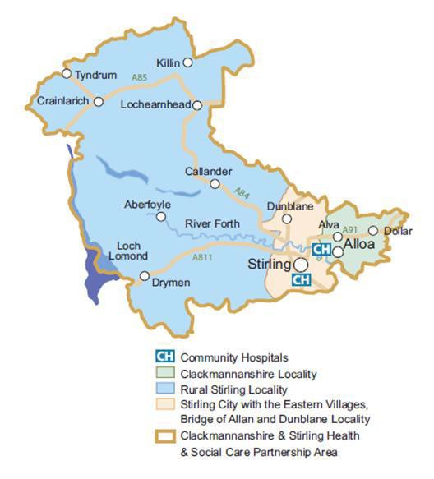
Communities are empowered to co-design service provision within their local areas within the Locality Planning Networks and their Locality Action Plans. There are three localities with the HSCP area Clackmannanshire, Rural Stirling and Urban Stirling.

Population

 | Clackmannanshire | Rural Stirling | Urban Stirling
Population | 51,540 | 25,534 | 67,936
Aged 65+ | 10,718 | 5,979 | 12,812
There are three Locality Planning Action Plans establishing community priorities for each Locality area, these have been aligned with the Strategic Commissioning Plan.
Each of the Locality areas are distinct in their characteristics, geography and history, they therefore have identified different priorities and activities. The Locality Planning Networks work collaboratively to co-design and co-deliver services, oversee delivery of the priorities and activities within these communities to meet the outcomes of individuals.
Localities were an integral part of the engagement around developing this Plan, contributing to the response to system pressures and desired outcomes of communities. This will continue throughout the lifetime of this Plan.
More information on Localities and how to participate can be found here (LINK TO WEBSITE PAGES).

Enabling Activities – How we do this.
Enabling activities describes the practical and organisational conditions that create the conditions that help the delivery of services. There is a need to understand the resources (budget, staff, equipment and systems), who are our partners and stakeholders (service users, their families and carers, third sector and independent providers, communities), how we are performing and if we need to change the way we deliver services. These are defined as Finance, Workforce Planning, Commissioning, Transformation, Data and Service Planning. Each of these are part of the technical process we carry out to plan our services alongside engagement with people and communities.

Finance & the services we provide
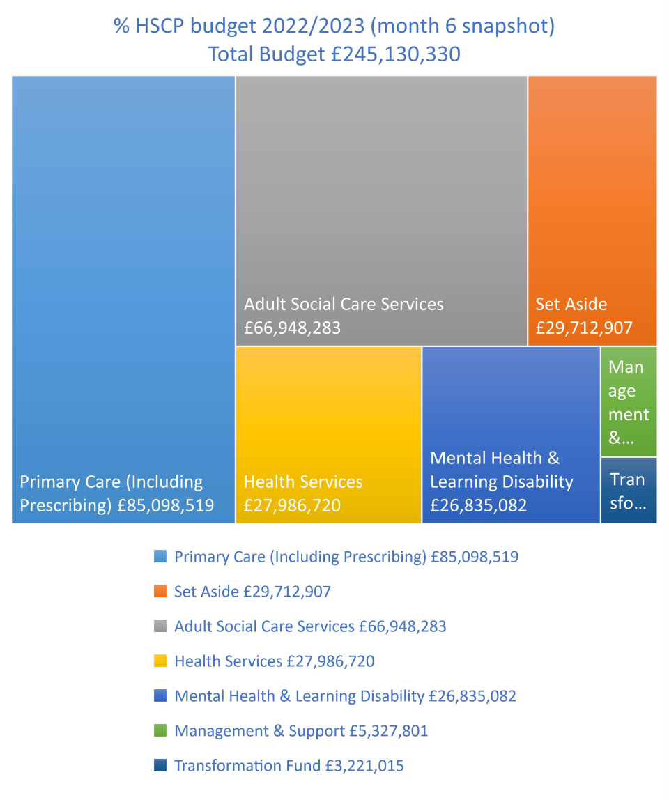

We should make comment about likelihood of a reducing budget and no wage uplift from LAs

Integrated Workforce Planning
The Integrated Workforce Plan 2022-2025 sets out a process that is a continuous improvement cycle based on Plan, Do, Study & Act, to ensure that we are a dynamic and flexible organisation, capable of responding to system changes. In line with the principles of effective local planning, the Integrated Workforce Plan is focused on a healthy and confident workforce, good engagement with partners including staff side and trade unions, delivery of person centred care and a human rights based approach.
We recognise that our workforce and strategic partnerships are our most valuable resources and we could not provide the care and support across our communities without the dedication of our own staff, providers, communities and partners.
The Integrated Workforce Plan outlines the key steps to the re-design and modernisation of community health and care workforce, which is being delivered through the development of our new Strategic Commissioning Plan and our ambitious programme of transforming care. The Plan was developed using the Skills for Care model of self-assessment and guidance produced by the Improvement Service. The Integrated Workforce Plan was designed using the five elements called pillars: Plan, Attract, Train, Employ and Nurture as described within the National Workforce Strategy for Health and Social Care published by the Scottish Government in April 2022.

The Integrated Workforce Plan was developed in partnership with staff, staff side and trade unions through a series of co-production workshops, focused on each of the elements of the five pillars. Staff and partners with a role in providing health and social care services were encouraged to participate; this model of engagement will continue throughout the life of the Integrated Workforce Plan alongside the delivery of the improvement actions identified. This work compliments and aligns to our Locality Planning Networks where we are co-designing our services with people with lived and living experience.
Workforce Challenges
There continue to be a number of workforce challenges across the whole sector; recruitment of specialist health and social care / social work staff continues to be problematic. Where there are vacancies, existing staff can experience stress and additional pressure as such the well-being of all staff is a key priority. Succession planning, learning and development and working with partners, third sector, independent sector, school, colleges and universities are ways we are exploring and developing to mitigate system pressures.

Further details of our Integrated Workforce Plan can be found here: (link to website)

Transformation

The need for change
The HSCP is committed to the delivery of safe, high quality services, however there continues to be significant and ongoing system and delivery pressures with a context of a challenging financial envelope. This is compounded by an increasingly ageing population many of whom have significant ill health and issues of co-morbidity. Public expectations continue to grow for flexible and person centred services.
As such, there is a need to review how support and care is delivered across communities and a desire to transform services to meet individual outcomes and public expectations within a context of financial responsibility. As described earlier in this Plan, the delivery of all services must be done in the context of Best Value; ensuring there is good governance and effective management of resources, to deliver the best possible outcomes for the public.
Delivery of care and support is needs led but also resource bound therefore we cannot continue to do what has always been done, there is a need to innovate and transform.

Transformation within the context of the HSCP Strategic Plan

Delivering this Plan requires change to be made; there are two main categories of change, Transformation and Continuous Improvement.
- Transformations are distinct changes to the way an organisation conducts business and usually requires temporary additional staff and financial resource to deliver. Transformation often demonstrates a step change in the way a service is structured or delivered and are justified by the benefits they create. Benefits can range from improved service user experience, to numbers of people receiving preventative/early interventions, or costs avoided.
- Continuous Improvement refers to gradual processes of evolution is usually delivered by existing staff within current budgets.
An ambitious programme of Transforming Care and health and social care modernisation is underway across the delegated services within the HSCP; focused on building community capacity; development of strategic partnerships; creating the conditions for integrated & multi-disciplinary working; delivering on ongoing legislative requirements and modelling person centred & outcomes based care and support delivery.

Scottish Approach to Service Design (SAtSD)
The Scottish Approach to Service Design establishes engaging people in the delivery of services as integral to reforming public sector services. It places focus on people with living and lived experience designing services to meet their needs and fulfil their rights. It looks at co-designing services collaboratively and not around the structures of the public sector.

The development of the Strategic Commissioning Plan and the Workforce Plan aligns naturally with the Scottish Approach to Service Design. Throughout the engagement sessions, working together in partnership with all the organisations, services and people

The seven principles of SAtSD |  | Getting the right people around the table to design and resource services has been a recurring theme in the engagement sessions to develop the Workforce Plan and the Strategic Commissioning Plan. There is a desire for everyone involved to looks at the ‘service journey’ and have this aligned to the rights and needs of the individuals engaged with services. By looking at the whole journey, we can also look at reducing stress and pressure, duplication of effort and provide more efficient and effective services.  The Strategic Commissioning Plan and the Scottish Approach to Service Design is also focused on early intervention and prevention, we want to connect with people before they move into crisis where possible.  Our approach to service design is collaborative and holistic. We will look to understand people’s lives, circumstances and design services around these, with their rights and needs central to this work. Engaging people with lived and living experience and the people who deliver services is integral to getting it right. Bringing together relevant data and research will provide the context of the service and the Commissioning Consortium model then creates the culture to design and deliver services collaboratively out with the constraints of organisational structure.
- We explore and define the problem before we design the solution.
- We design service journeys around people and not around how the public sector is organised.
- We seek citizen participation in our projects from day one.
- We use inclusive and accessible research and design methods so citizens can participate fully and meaningfully.
- We use the core set of tools and methods of the Scottish Approach to Service Design.
- We share and reuse user research insights, service patterns and components wherever possible.
- We contribute to continually building the Scottish Approach to Service Design methods, tools and community.

Our Data and Intelligence
There is a requirement within a robust model of strategic commissioning to have a range of intelligence sources including nationally published data, live local information and access to community intelligence. Sources can range from national and Scottish government published data, local social work and health recording systems as well as community based statistics of prevalence. Each of these build a picture to better understand the needs of people living in Clackmannanshire and Stirling.

The following information provides an overview of some of the in-depth work carried out in the Strategic Needs Assessment and the Scottish Burden of Disease work. These can be found here: (LINK to website).and on page x

Data and Performance

In the current climate, the way we live our lives is changing at an unprecedented rate. There is a need to operate as a whole system strategic partnership and to fundamentally change the model of delivery of strategic commissioning and local care and support. There is a need to understand the needs of people within our communities, the future demand on services and achieving good value for money. Information and intelligence is a vital asset in supporting the delivery of services in this way. How we use our data impacts how we provide the best possible services for local people.

Population figures and projections help us identify the levels of need, prevalence of common medical conditions and the recording of poverty, deprivation and life expectancy data helps understand the future requirements, and subsequently leads to better planning and commissioning of care and support services.

Data/Business Intelligence

For people: helps us understand the people who live here, putting them at the heart of our plans to deliver health and social care.

For services: having the right information and processes to make decisions in the way that we deliver services and budgets for today and the future

For transformation: getting the most out of our data, basing our choices on the strongest analysis and using data to transform our services.

Strategic Needs Assessment and Burden of Disease Population

Current population and projections
145,010 people live in the Clackmannanshire & Stirling area. Clackmannanshire population 51,540 people
Stirling population of 93,470 .

16.4% (23,825) are children and young people aged 0-15
63.2% (91,676) are working age people aged 16-64
20.4% (29,509) are aged 65+.

The overall population is expected to continue increasing over the course of this Plan.
Clackmannanshire total population expected to decrease slightly
Stirling expected to increase by about 4,000.

Percentage population increase from 2018-2038
 | All Ages | 0-15 | 16-64 | 65+ | 75+
Scotland | 2.5 | -10.2 | -10.2 | 21.8 | 54.6
Clackmannanshire | -2.0 | -9.3 | -9.3 | 21.1 | 67.8
Stirling | 8.9 | 0.0 | 0.0 | 24.8 | 53.8
Source: Population Projections 2018, NRS

This table shows the population aged 0-64 decreasing for Scotland and Clackmannanshire and no change in Stirling.

However, when we look at ages 65 and over, the population increases by 20-25%. This increase is even more significant when we look at those aged 75+, with an increase of 53.8% by 2038 in Stirling and 67.8% in Clackmannanshire

Life expectancy
Life expectancy helps identify health inequalities, and there is variation across the HSCP. Female life expectancy in Stirling is 81.9 years and in Clackmannanshire is 80.6 years. This compares to 81.0 in Scotland. For males, Stirling has the highest life expectancy at 77.6 years, above the Scottish life expectancy of 76.8 years and Clackmannanshire males have a life expectancy of 76.2 years, slightly below Scotland. Details of this can be found in our Strategic Needs Assessment (LINK).

Healthy life expectancy is about 60, this means that more people are living with conditions from 60 and may therefore need health and social care to support them to live full and independent lives.

Poverty & Deprivation
The SIMD is a tool for identifying areas of multiple deprivation in Scotland. Deprived does not mean just low income, but also that people have fewer health and education outcomes, opportunities and access to services.

Where there is low income and fewer health outcomes, health can also be poorer.

In Clackmannanshire & Stirling, 25,884 people (17.8% of the population) live in SIMD Quintile 1 areas.

This information helps us understand the needs of the population and is in more detail in our Strategic Needs Assessment (link).

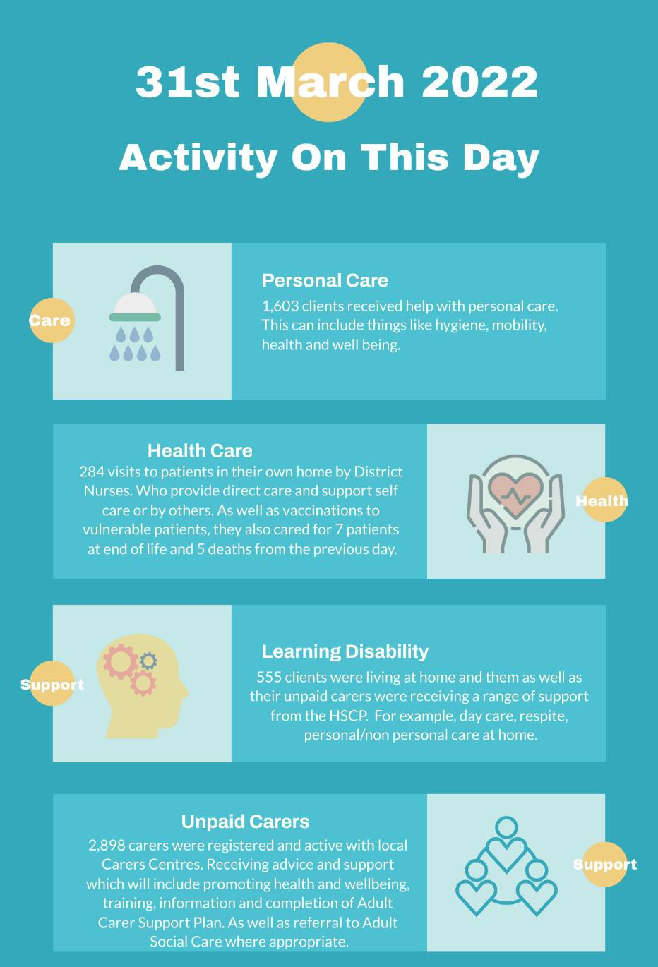

Health and social care needs

- 73% of people living in Clackmannanshire and 72% of people living in Stirling consider their health to be good or very good.

- In Clackmannanshire 32% of people are living with a limiting long term illness or condition, In Stirling, 40% of people are living with a limiting long term illness or condition. This compares to 34% in Scotland.

- In 2019, 668 adults with learning disabilities (272 in Clackmannanshire and 396 in Stirling) were known to the local authorities.

- In 2019, 668 adults on the Autistic Spectrum were known to councils (272 in Clackmannanshire & 396 in Stirling).

- There are approximately 21,250 unpaid carers in Clackmannanshire and Stirling area. 12,958 people identify as unpaid carers and it is estimated that there are 8,000 unknown unpaid carers.

- In Clackmannanshire 20.93% and in Stirling 16.75% of the population were prescribed medication for anxiety, depression and psychosis. This compares to 19.29% in Scotland.

- The Scottish Health Survey found that 20% in Clackmannanshire and 17% of people in Stirling are current smokers, compared to 16% in Scotland.

Scottish Burden of Disease
The Scottish Burden of Disease study is a national and local population health study that monitors how diseases, injuries and risk factors prevent the Scottish population from living longer lives in better health.

Leading group causes of ill health and early death Clackmannanshire
The three leading groups of causes of ill-health and early death in Clackmannanshire are cancers, cardiovascular diseases (coronary heart disease, stroke, peripheral arterial disease and aortic disease) and neurological disorders (brain and spinal cord tumour, cerebral palsy, dementia, epilepsy and seizure, etc.). These groups of causes account for 48% of the total burden of disease.

Reasons for ill health in Clackmannanshire | Reasons for early death in Clackmannanshire
1 Depression | 1 Ischemic heart disease
2 Low back and neck pain | 2 Lung cancer
3 Headache disorders | 3 Drug use disorders
4 Anxiety disorders | 4 Alzheimer’s disease and other dementias
5 Diabetes mellitus | 5 Other cancers
6 Osteoarthritis | 6 Cerebrovascular disease
7 Alcohol use disorders | 7 Chronic obstructive pulmonary disease
8 Drug use disorders | 8 Lower respiratory disease
9 Cerebrovascular disease | 9 Colorectal cancer
10 Other musculoskeletal disorders | 10 Cirrhosis and other chronic liver diseases
The table above shows the leading individual causes of ill health and early death in Clackmannanshire. The conditions highlighted in red are where Clackmannanshire has a higher rate than Scotland.
The leading cause of ill health in Clackmannanshire is depression, the rate in Clackmannanshire is 6.9% higher than in Scotland. Depression and anxiety disorders are two of the major causes of ill health in Clackmannanshire higher than the Scottish average at 6.9% and 6.7%.
The leading cause of early death in Clackmannanshire is ischemic heart disease, and the rate in Clackmannanshire is 69.36% higher than in Scotland. Leading risk factors for Ischemic heart disease include poverty, smoking, lack of exercise, diabetes, obesity and high blood pressure.

Leading group causes of ill health and early death in Stirling
The three leading groups of causes of ill-health and early death in Stirling are cancers, cardiovascular diseases (coronary heart disease, stroke, peripheral arterial disease and aortic disease) and neurological disorders (brain and spinal cord tumour, cerebral palsy, dementia, epilepsy and seizure, etc.). These groups of causes account for 48% of the total burden of disease.
Reasons for ill health in Stirling | Reasons for early death in Stirling
1 Low back and neck pain | 1 Ischemic heart disease
2 Depression | 2 Alzheimer’s disease and other dementias
3 Headache disorders | 3 Lung cancer
4 Anxiety disorders | 4 Other cancers
5 Osteoarthritis | 5 Drug use disorders
6 Diabetes mellitus | 6 Cerebrovascular disease
7 Other musculoskeletal disorders | 7 Chronic obstructive pulmonary disease
8 Age related and other hearing loss | 8 Lower respiratory disease
9 Cerebrovascular disease | 9 Cirrhosis and other chronic liver diseases
10 Skin and subcutaneous diseases | 10 Colorectal cancer

The table above shows the leading individual causes of ill health and early death in Stirling and comparison with Scotland. The conditions highlighted in red are where Stirling has a higher rate than Scotland.

The leading cause of ill health in Stirling is low back and neck pain, the rate in Stirling is 4.1% lower than in Scotland.
Depression and anxiety disorders are two of the major causes of ill health in Stirling however, they are lower than the Scottish average by 10% and 9.4%.

The leading cause of early death in Stirling is ischemic heart disease, and the rate in Stirling is 16.5% lower than in Scotland. Leading risk factors for ischemic heart disease include poverty, smoking, and lack of exercise, diabetes, obesity and high blood pressure.

Integrated Performance Management Framework

A Performance Management Framework supports effective monitoring of progress against this Plan and the agreed priorities. Performance reporting against this integrated performance framework will monitor, maintain and improve performance in line with an agreed set of objectives.

We are currently reviewing our Performance Management Framework to link the priorities set out in the Strategic Commissioning Plan to the national outcomes, statutory and operational requirements.
The progress in delivering this Strategic Commissioning Plan will be monitored and reported regularly through performance reports. Action Plans will set out key actions, performance indicators and risks and reporting for each of the key priorities and activities. The Integrated Performance Management Framework sets out the legal reporting requirements, the governance arrangements and the performance indicators used to demonstrate progress against priorities local and national.
Containing Clackmannanshire and Stirling level information relating to the functions of the IJB such as issuing Directions, decisions about commissioning, assurance that the HSCP is delivering the key actions as identified for each priority area. Thus ensuring we are able to measure and report on the health and social care outcomes for the people of Clackmannanshire & Stirling.
The purpose of the Integrated Performance Framework is to demonstrate continuous improvement, promote accountability and transparency, deliver governance and provide assurance to the people who use our services and the people who provide our services.
More information on our Performance can be found here (LINK TO PERFORMANCE SECTION on website)

Another Section – Working in Partnership?
Housing, Adult Social care, care & clinical governance??/

Housing Contribution to Health and Social Care

National Context  Secure, good housing is key to tackling to inequalities and improving physical and mental health and wellbeing. Affordable, warm, safe, secure and accessible homes plays a significant role in supporting people within their communities.  The Scottish Government’s Housing to 2040 strategy sets out an aspirational future for housing in Scotland. It is focused around the diversity of our people and communities and delivering high quality, sustainable homes, sustainable communities that are connected and vibrant, and homes that meet people’s needs. Homes that supports wellbeing and the different stages of our lives. | 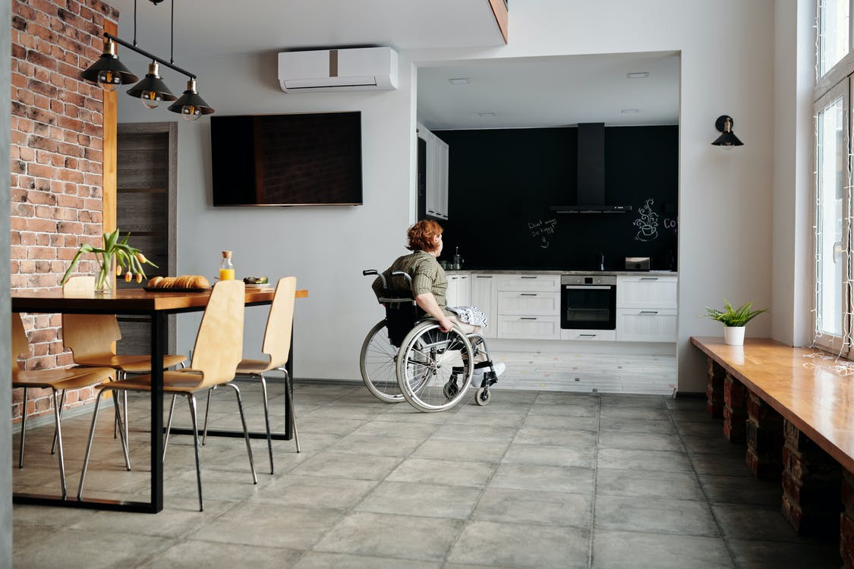

Local Context
Clackmannanshire & Stirling Local Housing Strategies set out their strategic approach in delivering high quality housing and housing related services across all tenures. Working in partnership we will continue to deliver and design housing that meets the needs of our people.

The Housing Contribution Statement is an element of the partnership working between Local Housing Strategies and delivering effective health and social care services. It puts the needs of the people at the fore of planning. The Local Housing strategy is produced by local authorities and assess housing needs, demand and condition, including specialist housing, such as accessible or adapted housing, wheelchair housing and service that support independent living.

Housing Contribution Statements are aligned to the vision to support people to live independently in their own home and to ensure people are in the right place with the right support for them.

Stirling Council Local Housing Strategy 2022
Clackmannanshire Local Housing Strategy 2012-2017.

Adult Support & Protection
Adult Support and Protection (ASP) seeks to support and protect adults unable to protect their own wellbeing, property, rights or interests, who are at risk of harm or abuse. This may be due to a physical disability, mental disorder, illness or infirmity that makes them more vulnerable. Harm can be physical, psychological (feeling fear, alarm or distress), harm to property, rights or interest such as theft, fraud, embezzlement or extortion or where someone is self-harming. We all have a responsibility to report where we know or believe and adult to be at risk of harm.

The Adult Support and Protection (Scotland) Act 2007 has brought about significant changes in the way adults considered to be at risk of harm are supported and protected. Our new Adult Support Protection Strategic Improvement plan sets out our priority areas, success measures and aims. LINK

The plan builds on achievements from the previous improvement plan and draws on learning from the year2022? ASP Thematic Inspection by the Care Inspectorate; self-evaluation, audit activity; performance data, sub-groups, short life working groups, stakeholder feedback and Learning Reviews. The Adult Support and Protection Committee oversees delivery and the respective Sub Groups report to the Chief Officers Group (COG) to offer further scrutiny and oversight of the plan.

ASP Strategic Improvement Plan has been devised to deliver on national and local policies and is based on five key priority areas.
- Leadership & Governance
- Proactive Improvement
- Workforce Development
- Improving outcomes for individuals with lived experience and carers
- Promoting Adult Support and Protection Awareness
The Strategic Improvement Plan reflects the themes within the Strategic Commissioning Plan, by putting the rights of adults at risk of harm first and ensuring they shape the services they need. It commits to working with others to put trauma informed and responsive practice in place across our workforce and services. We work with each individual based around their abilities, background and characteristics (including age, sex, sexual orientation, religious persuasion, racial origin, ethnic group, cultural and linguistic heritage) towards achieving their outcomes through informed choice and control.
We aim to deliver services that wherever possible are actively informed by people with lived experience. We will ensure people with lived experience are heard, valued and supported, enabling them to discover their potential and realise their ambitions. We will recognise the importance of meaningful relationships that offer collaboration, choice, empowerment, safety and trust as part of a trauma informed approach.

Looking Forward

The development of a ten year Strategic Commissioning Plan demonstrates our commitment to our people and staff and services. We will continue to be proactive and innovative in how we operated within our environment and work to shape the future of health and social care in Clackmannanshire and Stirling and nationally.

This Strategic Commissioning Plan is the very beginning of the process, it has set out the intention to co-produce and co-design services with the people at the very centre of the services, those who have lived and living experience of services and conditions, and those who deliver the services. Engaged and empowered communities

2021 National Records of Scotland
Quintile 1 is considered the most deprived and Quintile 5 the least deprived.

