**Right Care Right Time Transformation Programme – v3 Final Draft**

|  |  |
| --- | --- |
| **Author:** | **Maxine Ward & RCRT Oversight Group** |
| **Date:** | **18 January 24** |

Update and further information regarding the Right Care Right Time Programme, which will transform the way social care operates across the Partnership.

**Background**

The Right Care Right Time programme builds upon the recommendations of the David Welsh report from his Review of Adult Assessment & Review Processes in 2021 as well as other good practice identified in the period since.

**Introduction**

The Right Care Right Time programme will transform the processes and operational delivery of services. There are challenges across the system as a result of a lack of cohesive and consistently applied processes that support an understanding of demand, efficient management of demand and sufficient oversight of performance that enables effective alignment of resource. A process and flow model has been drafted to help understand where the pressures are across our system, reduce waiting times and ensure people are directed to the right support at the first point of contact.

It has been developed with the intention of wider engagement with frontline staff to test its viability and to enable staff to deliver the best outcomes for people needing care in the community. The process, and indeed wider programme of transformation, considers an analysis of pressures at specific points across the system that create bottlenecks and delays, reduces optimal practice in relation to enablement approaches, timely reviews and challenges of capacity to release time to focus on prevention and early intervention, and building relationships with those accessing services.

The Right Care Right Time Programme aims to achieve the following outcomes:

* 1. Improve Service User Experience by creating more efficient processes that reduce reliance on pending lists.
  2. Reduce the Costs of Care, where possible, by providing the right care at the right time with regular reviews and signposting for outcomes.
  3. Support Workforce Wellbeing through the development of clear, efficient and easy to use processes.

**The Model**

At the heart of this programme is the new Front Door Service (FDS) that will be the receiving team for all referrals for people not currently known to us. This team will be trained to help signpost for outcomes, meaning someone is able to access useful information regarding their concerns in their community, as not everyone will need statutory service provision.

The draft model set out in Appendix 1 suggests a new and improved flow of referrals across the whole system that is supported by clear and consistent written operating procedures and defines the criteria and movement of referrals from one part of the system to another. In doing so it aids understanding of demand to ensure resource is appropriately allocated to each part of the system. It provides a consistent approach for onward referral or closing of interventions to prevent delays, pending lists and staff feeling overwhelmed with workloads.

The model is reliant upon a multi-agency weekly hub where non-urgent referrals can be discussed with professional and third sector colleagues to ensure the right person is able to provide the right support with minimum amount of intervention and a reduction of dependency on statutory services. Experience of this type of model in East Ayrshire has shown that very few referrals from each week are carried over into the next week.

For anyone who is already known to social work, their case will bypass FDS and go directly to their social worker within the locality teams, CHART or the Care at Home review team (currently being established). Whilst this reduces the need for ‘duty rotas’, Locality Teams will require to have availability of staff to pick up urgent referrals if the allocated staff member is absent from work.

In addition, a resource allocation group (RAG) is being created to authorise requests for Long and short term care to improve governance, ensure statutory reviews are undertaken and reduce the number of people residing in care homes.

The model has been presented at Team Leader level for their views initially to support amendments before seeking the views of frontline staff and Appendix 2 outlines questions and answers from those sessions to support analysis and understanding.

**Projects within the Programme**

There are distinct projects that sit below the Right Care Right Time programme, these include the Care at Home Review team and work on RAPID.

Care at Home Review team

The new processes, as shown in Appendix 1, outlines the process for implementing care at home packages and the operating procedures will be clear about responsibilities in the assessment and initial 4 week review of the provision of those services. The case will then be transferred to the Care at Home Review team to schedule future annual reviews. The operating procedures will be jointly written by frontline staff / managers and the Business Matching unit to ensure business processes and bureaucracy do not create further delay in the system or additional work for frontline staff. However, BMU will support us in ensuring our commissioning and procurement responsibilities are upheld within the new operating procedures. This process also supports our performance reporting on statutory responsibilities.

The Care at Home Review team will be recruited on a 2-year fixed term basis that will operate across both council areas and will consist of one Team Leader, two Social Workers and five Social Care Officers. The critical financial pressures we are currently experiencing means that this team will need to have a clear focus on reducing dependency on care at home services and promoting greater independence and self-management.

RAPID

While work on RAPID has already begun, with a focus on reducing waiting times for enablement, this phase of the project will focus on data and performance from a multi-disciplinary perspective to ensure we effectively use all of our services across the HSCP to support enablement in the most effective way. Key to this programme is the collaborative approach with AHP services, social care delivery and social work assessment processes. An enablement ethos will be central to every aspect of service delivery across this programme and will be an essential requirement for any new packages of care to ensure we support people to achieve their maximum potential for independence. Data will be collected at regular reviews to assess the impact of reablement on improving independence and reducing packages of care.

**Staffing**

It is important to acknowledge that alongside improving service user outcomes, practice and performance against Key Performance Indicators and staff experience, this programme of transformation aligns to the critical need to deliver a significant level of savings.

The Care at Home Review Team is being funded on the basis that the savings it will generate will sufficiently cover the running costs and this has determined the fixed nature of the contracts being offered at present. A review of this service will be undertaken to ensure it has delivered on the anticipated savings and can therefore be continued on a permanent basis.

The FDS model, however, has a somewhat different framework of delivery in that we expect the model to reduce the number of referrals coming into our teams and there is, therefore, no requirement for additional staff. The model considers the resource needed to support that reduced footprint of referrals and the subsequent available capacity to service the FDS. In essence, the staff to support FDS will come from existing teams.

The senior leadership team are aware of the frustrations felt by all as a result of the delay in progressing the recommendations from the David Welsh review and hope that the engagement with frontline staff over the coming months will create interest in the particular skill set that will be required in FDS and ownership for involvement in the continued design and implementation of the model.

**Next Steps**

As this is a new way of working staff are vital to the success of this project. A presentation and initial feedback was sought at the Team Leaders meeting on 18 December 2023. However, this is only the beginning of engagement with staff. There are workforce meetings scheduled for January 2024 (23rd for Clackmannanshire and 24th for Stirling) where more information and discussion will evolve. The model is a draft proposal at this time with the expectation that its final shape will be influenced by frontline views, opinions and experiences.

In addition, more in depth background work will need to take place to help define processes and the operation of the model, this is yet to take place and will rely on the involvement of staff.

**Appendix I**

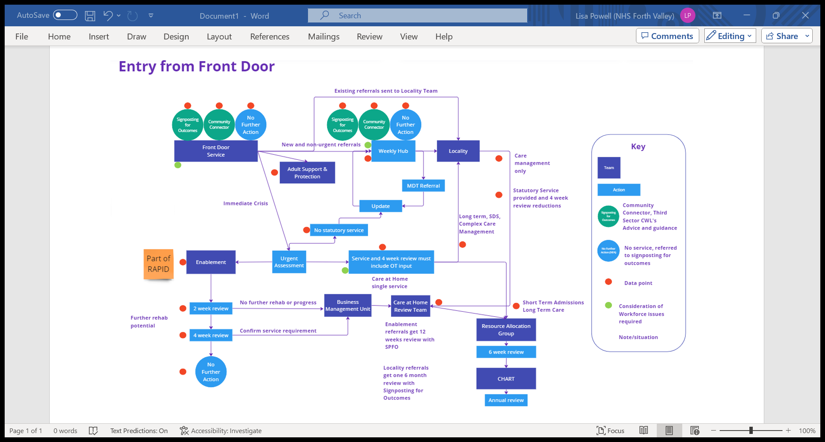

**Appendix II**

**Questions raised at the Team Leaders Meeting on 18 December**

Q: Who will chair the weekly Hub meetings?

A: Initially this will be the Social Work Team Manager, but they will need support from Locality Managers to embed the ethos of the collaborative approach.

Q: What if there is a disagreement in a Hub meeting?

A: As this is a multidisciplinary meeting, decisions will be made amongst attendees but any continued disagreement will be resolved by Locality Managers.

Q: Will there be a minute of the Hub meetings?

A: There will be dedicated admin support that will track the progress of each referral that is signposted to other services and ensure follow up on each case eg when a referral can be closed or intervention is complete to ensure appropriate audit trail of intervention and decisions.

Q: What about the pending lists? These are currently very high and people will still be on them when this model begins.

A: There are already identified bottlenecks in current model. Prior to go live there will be a piece of work to reduce these as much as possible before the new model begins.

Commissioning processes will also be reviewed to reduce delays in the provision of care and reduce the burden of paperwork on frontline staff in commissioning care.

Some work is already in progress with SDS Forth Valley and their ‘Well Worthwhile Waiting’ project that aims to support and manage the expectations of people already waiting for assessment.

Q: How will urgent assessments work, who will do this?

A: Staff working in FDS will do urgent visits and enquires without investigatory powers (for ASP) e.g desk-based exercises to gather more information and SW’s in FDS will undertake ASP visits where required.

Q: What about if someone uses MECS?

A: These people will still come through the new Front Door if MECS is the only service they have in place.

If they also access other services or have had assessments and are known to social work, they will go to the allocated worker within the locality team.

Q: What about people in hospital who aren’t known to social work?

A: These will continue to be supported by the Hospital Discharge Team, so won't some to the social work Front Door.

Q: When does a case get handed to a team such as the Care at Home Review team?

A: This new process will improve accountability, for example before a care at home package is passed to the care at home review team the package must have an identified and authorised budget and must have had the initial 4 week review to confirm the POC is stable. If further complexities are identified that need longer term support then this is passed to the locality team to undertake and stabilise the case before transferring to the Review Team. Case File audits will also be undertaken prior to transfer to ensure practice and professional standards are consistently achieved. These processes will be outlined in the standard operating procedure.

Q: What about Adult Support and protection (ASP)?

A: ASP for people not known to the service will come through FDS but there will be much clearer delineation of when the case should transfer to a Locality Team if further work is required. Specifically, if the 3 point test is met and a case conference is required, the FDS will undertake all necessary intervention for immediate protection of the person and prepare for Case Conference. If the Case Conference decides ongoing support is required then this will pass to the Locality team at the point of Case Conference for the ongoing work and core group responsibility.

Essentially all work carried out at FDS should not exceed 4 weeks before being transferred to the most appropriate part of the system.

Q: Where does data fit into this?

A: Data continues to be really challenging for us when we are trying to plan the delivery of services and identify and understand where improvements are required. We have the full support of the HSCP Planning and Performance team who have a lead role in the delivery of the overarching programme of Right Care Right Time transformation work. They are helping us to map out the data we need to consider and design a framework for gathering and reporting on that information.